Analysis Artifacts for Use Case 03

**Table Of Contents**

1. **Build ERD by Mohanapriya** **2**
2. **Robustness Diagram by Khushmeet** **3**
3. **Class diagram by Vaishali** **3**
4. **Sequence Diagram by Tejaswi** **4**
5. **Communication Diagram by Mohanapriya** **5**
6. **State Diagram by Mohanapriya** **6**
7. **DFD by Kopal** **7**

# Build ERD by Mohanapriya

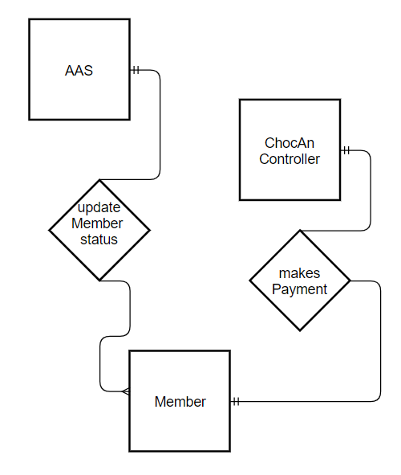

# 2. Robustness Diagram by Khushmeet

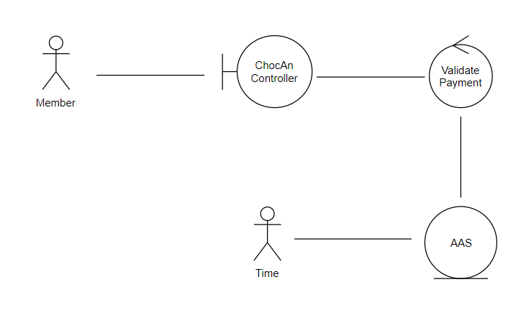

# 3. Class diagram by Vaishali

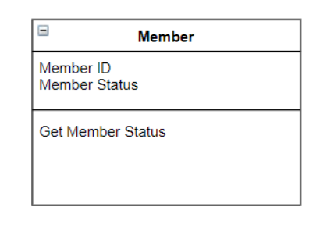

# 4.Sequence Diagram by Tejaswi

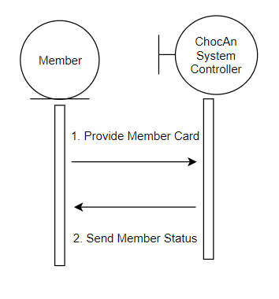

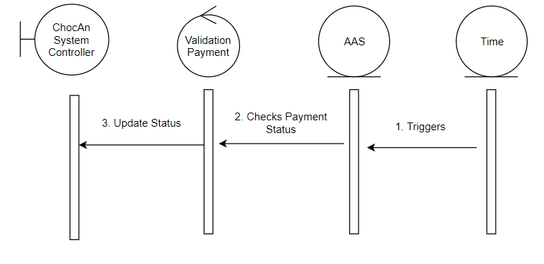

# 5. Communication Diagram by Mohanapriya

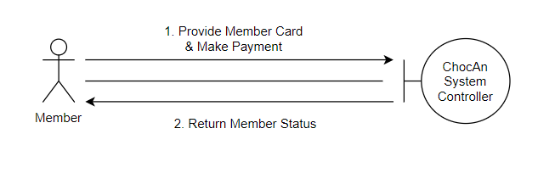

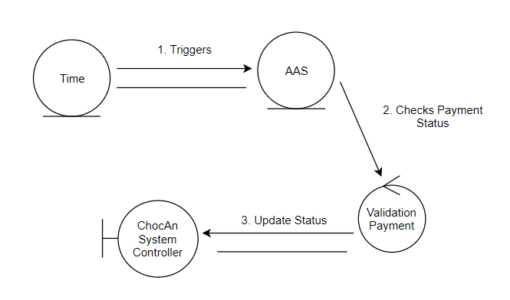

# 6.State Diagram by Mohanapriya

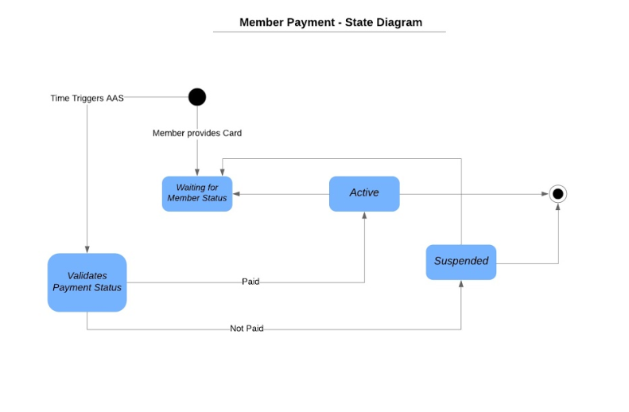

# 7. DFD by Kopal

